[WOBI-42] There is no information in the search box on what we suppose to look for while in the others search boxes it´s mentioned Created: 22/Jul/24 Updated: 22/Jul/24
Status: | To Do
Project: | Wobi

Type: | Bug | Priority: | Medium
Reporter: | Tomer Darmon | Assignee: | Unassigned

Attachments  : | 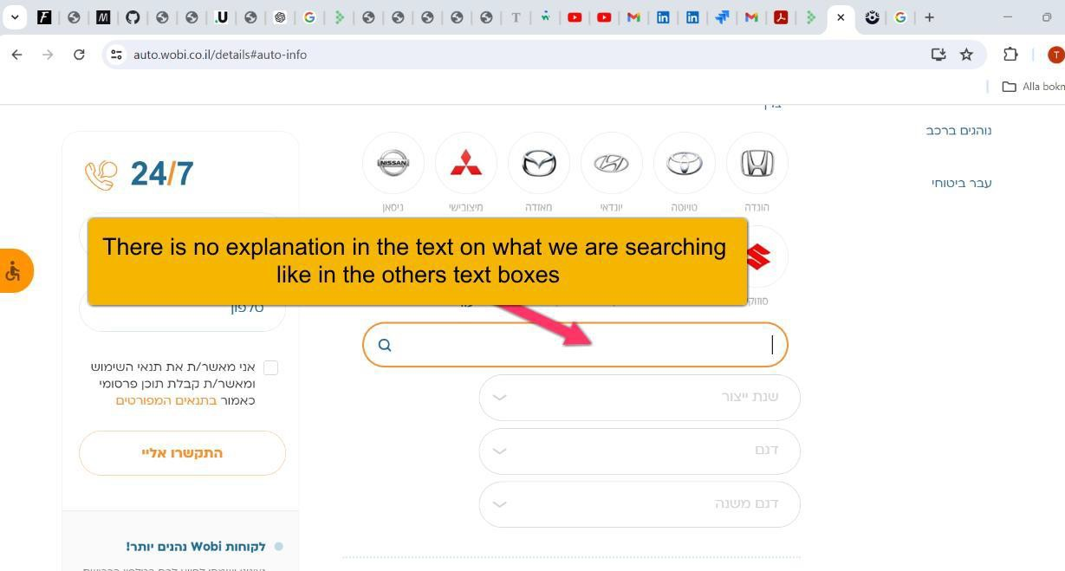
Severity: | S3-Major

Description
Steps to Reproduce :
- Open URL https://www.wobi.co.il/
- Choose the insurance “רכב ביטוח“
- Press on the tab “חובה + מקיף“
- Choose the insurance date and then press the tab “הרכב לפרטי המשיכו“
“אין לי מספר רישוי“ tab the Press 5.
6. In the new page press on the + icon
Actual Result: No description written inside the search text box to mention what we suppose to search
Expected Result: I would expect that there will be information of what is written inside the text box like in the others search field

60

